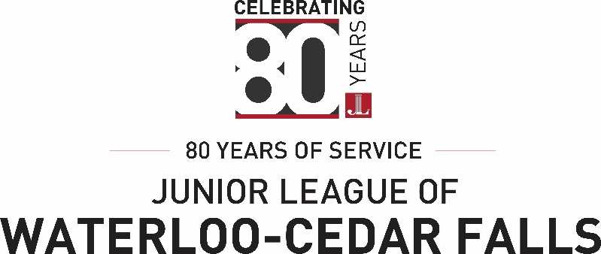

The Golden Rose Award honors Junior League Sustaining Members for their continued volunteer contributions to the community as well as their involvement in Junior League.

Selection Guidelines:
- One or two winners may be selected per year.
- Nominees must have been Active members of the Junior League of Waterloo-Cedar Falls for a minimum of three years.
- The Golden Rose may only be received once.
- There is no limit to the number of times a Sustainer may be nominated.
- Nominations may only come from Sustainers, Actives or New Members with no limit on the number of nominations an individual may make.
- The selection committee shall consist of members from the Membership Council and Chaired by the VP of Membership.

Please Complete and Return Form to:
Junior League of Waterloo-Cedar Falls
Attn: VP Membership
Box 568
Waterloo, IA 50704
Or email to:
jlwcfmembership@gmail.com

Golden Rose Nomination Form

Name of Sustainer Nominee

Nominator’s Name: Phone:

Please give specific reasons why this person is deserving of the Golden Rose Award

Please List the Nominee’s Volunteer and Leadership Roles

